HELPLINE NUMBERS AND EMAILS:

SL.NO | COMMITTEE NAME | CONTACT NUMBER | MAIL ID
1 | ANTI-RAGGING COMMITTEE | 9434033636 | dilsantiragging@gmail.com
2 | ANTI-RAGGING SQUAD | 7699999906 | dilsantiragging@gmail.com
3 | INTERNAL COMPLAINTS COMMITTEE (ICC) | 8637393622 | icc.dils@gmail.com
4 | EQUAL OPPORTUNITY CELL | 8918881646
5 | DISCIPLINARY & STUDENT GRIEVANCE REDRESSAL COMMITTEE | 9093936949 | dilsdisciplinarycommittee@gmail.com

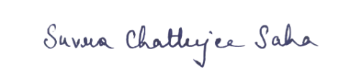

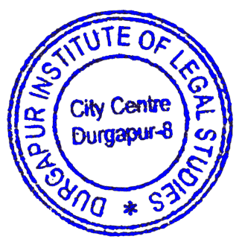

Mrs. Suvra Chatterjee Saha
Teacher-in-Charge

Durgapur Institute of Legal Studies (DILS)

